Part A — Use case diagram (20 min)
Show the actors, the system boundary and 5–9 use cases. Each use case is a goal in the actor's language, not a screen or a button.
@startuml
left to right direction

actor "Depot Clerk" as Clerk
actor Manager
actor Accountant

rectangle "Produce Intake and Payment System" {

(Record Produce Delivery)
(Calculate Payment)
(Issue Receipt)
(View Delivery History)
(Synchronize Records)
(Generate Reports)
(Approve Payment Adjustment)
(View Payment Records)

Clerk --> (Record Produce Delivery)
Clerk --> (Calculate Payment)
Clerk --> (Issue Receipt)
Clerk --> (Synchronize Records)

Manager --> (Generate Reports)
Manager --> (Approve Payment Adjustment)
Manager --> (View Payment Records)

Accountant --> (View Payment Records)
Accountant --> (Generate Reports)
}

@enduml

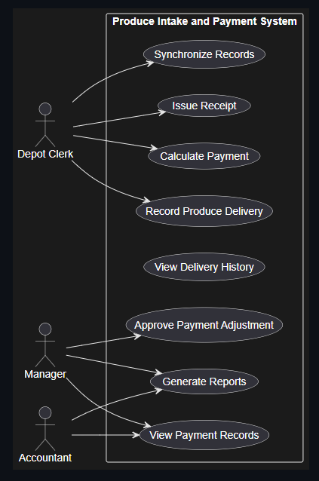

Part B — Class diagram (25 min)
Show 4–7 classes with attributes, key operations, named associations and multiplicity. Read your SRS: recurring nouns are candidate classes.
@startuml

class Farmer {
- farmerId
- name
- village
+ viewDeliveries()
}

class ProduceDelivery {
- deliveryId
- deliveryDate
- quantityKg
+ calculateValue()
}

class Payment {
- paymentId
- amount
- paymentDate
+ processPayment()
}

class Receipt {
- receiptNumber
- issueDate
+ printReceipt()
}

class SyncRecord {
- syncId
- syncDate
- status
+ synchronize()
}

class DepotClerk {
- staffId
- name
+ recordDelivery()
}

Farmer "1" -- "0..*" ProduceDelivery : delivers
ProduceDelivery "1" -- "1" Payment : generates
Payment "1" -- "1" Receipt : produces
DepotClerk "1" -- "0..*" ProduceDelivery : records
ProduceDelivery "1" -- "0..*" SyncRecord : synchronizes

@enduml

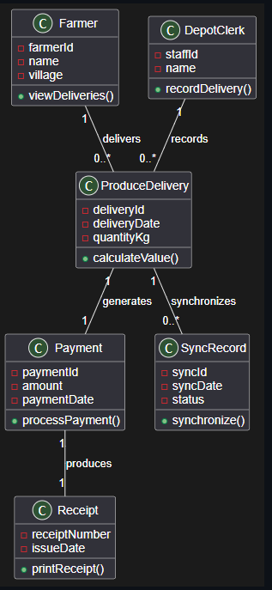

Part C — State diagram (20 min)
Pick ONE thing in your system that has a genuine lifecycle — a payment, an intake record, an application. Show its states, the triggers between them, and at least one guard.
@startuml

[*] --> Recorded : record delivery

Recorded --> Valued : calculate payment

Valued --> Receipted : print receipt

Receipted --> QueuedForSync : save locally

QueuedForSync --> Synced : network available

QueuedForSync --> QueuedForSync : retry sync

Synced --> Adjusted : [manager approves]

Synced --> [*]

Adjusted --> [*]

@enduml
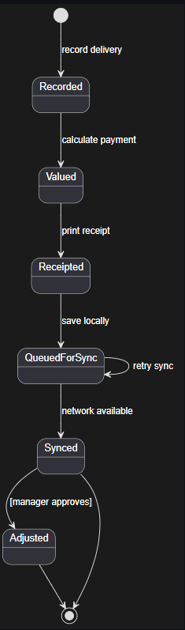

Part D — Activity diagram with swimlanes (20 min)
Model one workflow that crosses a boundary in your Week 5 deployment diagram. It must include a branch for what happens when the network or power is unavailable.
@startuml

|Depot Clerk|

start

:Record produce delivery;

:Calculate payment;

:Print receipt;

:Store record in local SQL database;

if (4G available?) then (Yes)

:Send synchronization batch;

|Town Office PC|

:Import records;

:Check transaction ID;

if (Duplicate found?) then (Yes)
:Skip duplicate record;
else (No)
:Save record;
endif

else (No)

|Depot Clerk|

:Keep records in sync queue;
:Continue recording deliveries;
:Continue printing receipts;

endif

stop

@enduml

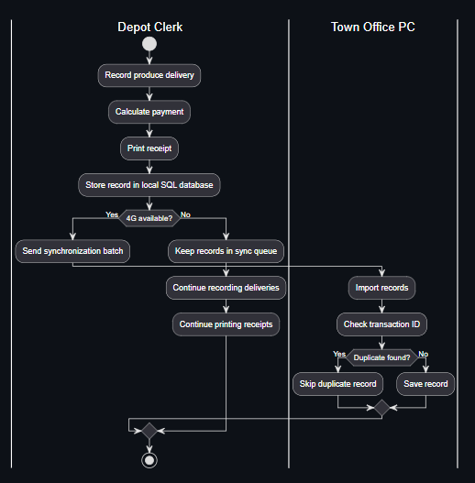

AI Use Declaration
I used Microsoft 365 Copilot to help create the initial PlantUML diagrams. I checked and updated all diagrams to match my SRS for the Waghi Valley Produce Cooperative system. All final changes, checks, and design decisions were completed by me.

